**Programmer’s Hub Web Application**

**Table of Contents**

1. Project Overview

2. Technologies Used

3. Objective

4. Authentication Flow

5. Features

6. Future Improvements

7. Project Outcome

8. Visual Overview of Programmer's Hub

9. Conclusion

# 1. **Project Overview**

**Programmer's Hub** is a Q&A website where programmers can ask questions, answer them, and interact with the community. It serves as a platform where users can share their knowledge and solve programming problems collaboratively. The website offers various features like user authentication, profile management, question and answer posting, and the ability to like and comment on posts. Additionally, the platform incorporates a like functionality for questions, allowing users to upvote the best answers. This interactive feature enhances user engagement and content visibility**.**

# 2. **Technologies Used**

* **Frontend**
* **React.js:** A JavaScript library for building user interfaces, used for creating dynamic and responsive pages.
* **HTML, CSS:** For creating and styling web pages.
* **React Router:** For navigating between different pages without refreshing the browser.
* **Font Awesome:** For icons like upvote, delete, user profile, etc.
* **Axios:** For making HTTP requests from React to the backend server.
* **Backend** 
  + - **Node.js:** For creating the server-side application and handling API requests.
    - **Express.js:** For routing and handling requests on the server.
    - **MongoDB:** A NoSQL database used to store user data, questions, answers, and other content.
    - **Mongoose:** An ODM (Object Data Modeling) library for MongoDB and Node.js, used for interacting with the database.
* **Authentication** 
  + **JWT (JSON Web Token):** A standard for securely transmitting information between parties, used for handling authentication.
* **Others Tools**
  + **MongoDB Compass:** A GUI for interacting with MongoDB.
  + **Postman:** For testing the API endpoints during development.
  + **VS Code:** Used as the primary code editor.

# 3. **Objective**

The objective of **Programmer's Hub** is to create a platform where programmers can collaborate, solve coding problems, and share knowledge. By allowing users to ask questions, provide answers, and engage with others' posts, the platform fosters a community of learners and experienced developers. The project aims to:

* Provide a clean and simple interface for users to interact with.
* Enable seamless and secure user authentication using **JWT.**
* Allow for easy management and viewing of programming-related content.
* Promote a collaborative and knowledge-sharing environment among programmers.

# 4. **Authentication Flow**

The authentication flow in **Programmer's Hub** follows these steps:

* **Sign Up**
* The user provides a name, email, and password.
* The password is hashed using **bcryptjs** for security before storing it in the database.
* The user is then issued a **JWT** token upon successful sign-up.
* **Login**
* The user provides their email and password.
* The system verifies the credentials and issues a **JWT** token for further use.
* This token is stored in the browser (typically in localStorage) to maintain the user's session.
* **Authorization**
* Every request requiring user data (like posting a question or answering a question) is authorized using the **JWT** token.
* If the token is invalid or expired, the user is redirected to the login page.
* **Protected Routes**
* **Routes** such as posting a question or accessing user profiles are protected and only accessible to logged-in users.

# 5. **Features**

* **User Management**
* Users can sign up, log in, and maintain a session using **JWT** for secure authentication.
* Each user has a profile displaying their name.
* **Q&A Interaction**
  + Logged-in users can ask new questions by providing a title and description. The **system validates** the input before posting.
  + Other users can answer questions and upvote questions based on their usefulness.
  + Each answer has a comment section for further discussion and feedback.
  + Users can reply to comments under their answers to keep conversations going.
  + Users can also upvote questions, helping to highlight the most important or helpful topics.
  + Every user has the ability to edit or delete their own questions and answers.
* **Navigation and UI**
* A Home page displays all the posted questions in a scrollable feed.
* A top navigation bar includes a search bar to find questions by title.
* A sidebar provides quick access to features like:
  + Home, Create Question & Your Questions
* Logged-in users stay signed in until they manually log out.
* The interface is designed to be clean and user-friendly for easy interaction.
* **Security**
* **JWT** Authentication is used to secure private routes.
* Passwords are hashed using **bcrypt** before storing in the database.
* Token is stored in localStorage to maintain persistent login.
* Only authenticated users can create, answer, or manage content.

# 6. **Future Improvements**

* **Search Functionality:** A more sophisticated search functionality can be added, allowing users to search by keywords, tags, or categories.
* **Tagging System:** Allow users to tag questions with relevant programming languages, frameworks, or topics for easier categorization and search.
* **Real-time Features:** Implement WebSockets or Server-Sent Events (SSE) to build a real-time notification system that alerts users when their questions are answered, liked, or commented on.
* **Admin Panel:** An admin panel can be added to manage users, questions, answers, and handle reported or inappropriate content through a dedicated interface.
* **Mobile App:** A mobile version of the application could be developed to extend its reach and usability.
* **Profile Pictures:** Allow users to upload and display profile pictures to personalize their accounts and improve user recognition across the platform.
* **Edit Profile:** Enable users to edit their profile information such as name, email, and password for better account management and flexibility.
* **Likes/Upvotes:** Implement a like or upvote system for questions and answers to encourage quality contributions and increase user engagement.
* **Answer Sorting:** Allow users to sort answers based on likes, newest, or most upvoted.

# 7. Project Outcome

By building **Programmer’s Hub**, I gained practical, end-to-end development experience with the MERN stack. Key outcomes include:

* Understood and implemented **JWT**-based authentication to secure user access and protect routes.
* Built **RESTful APIs** and performed complete **CRUD** operations across both frontend and backend.
* Applied React state management, component-based design, and dynamic routing to create a smooth user experience.
* Designed a responsive and intuitive UI using React, focusing on usability and modern design principles.
* Practiced modular coding and maintained a clean project architecture, making the codebase scalable and easy to manage.
* Gained hands-on experience in building a fully functional **Q&A** platform with features like post creation, commenting, authentication, and user interaction.
* This project significantly enhanced my understanding of full-stack development and prepared me to handle real-world web applications confidently.

# 8. **Visual Overview of Programmer's Hub**

* **Home**

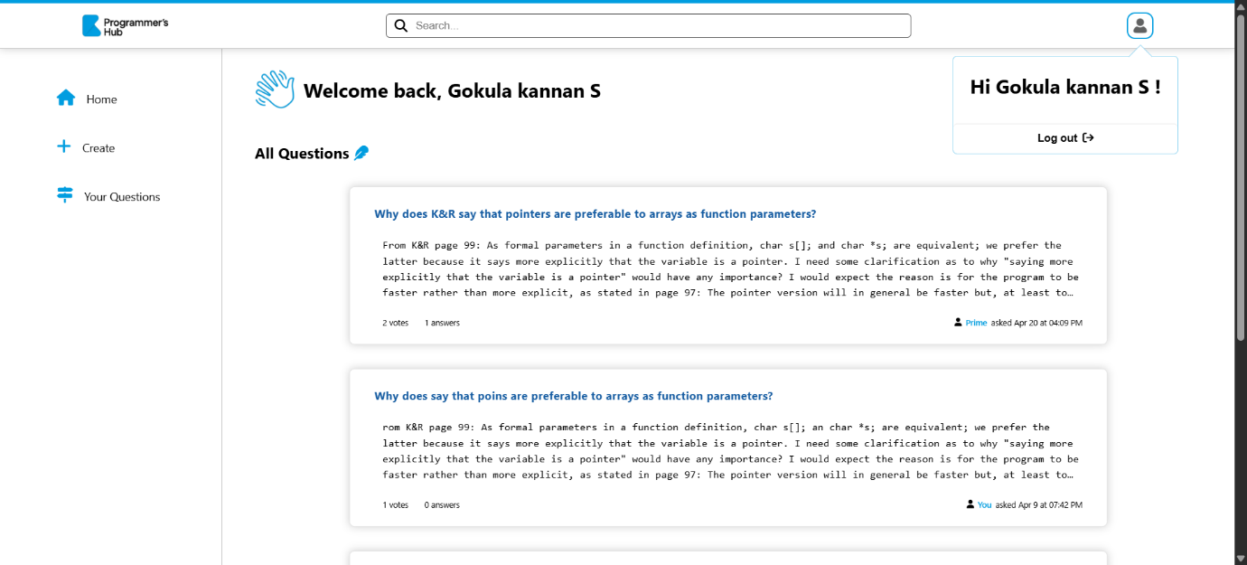

* **Without Login**

User cannot access the site without logging in.

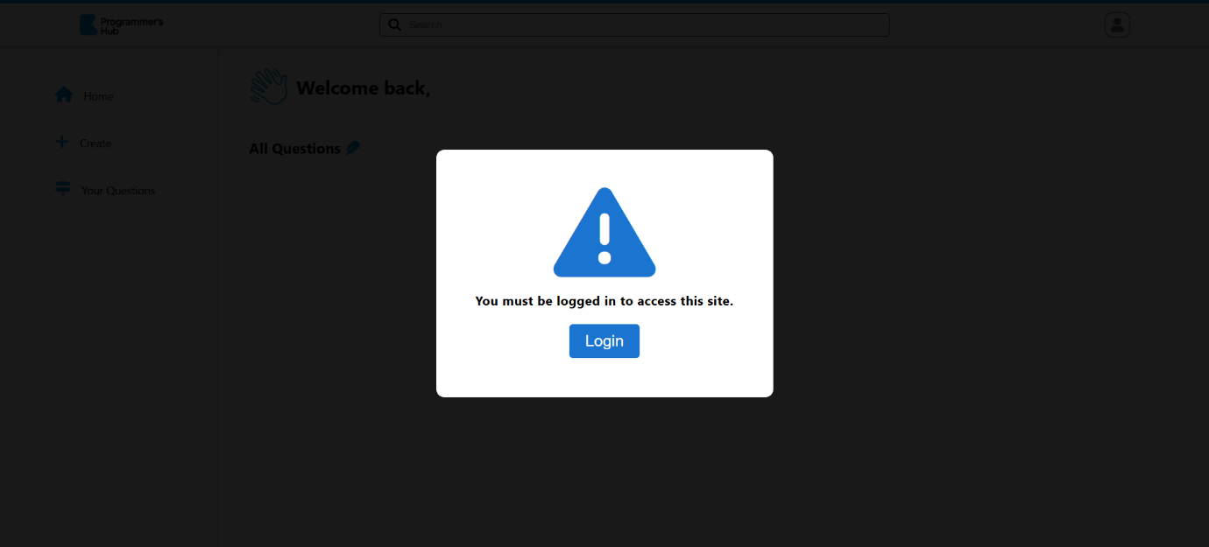

* **Login / Signup**

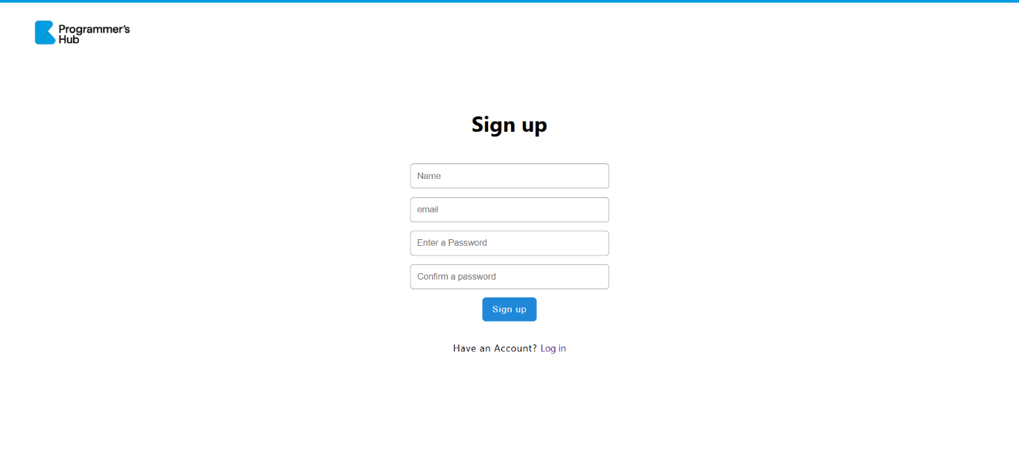

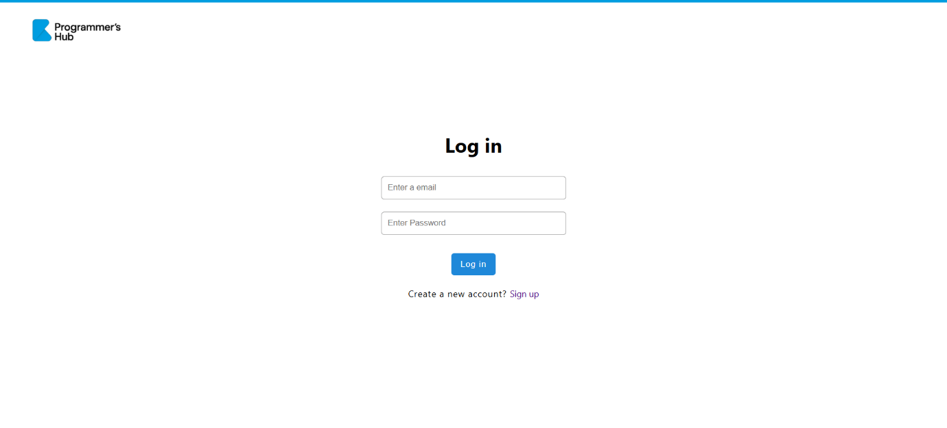

* **Question Page**

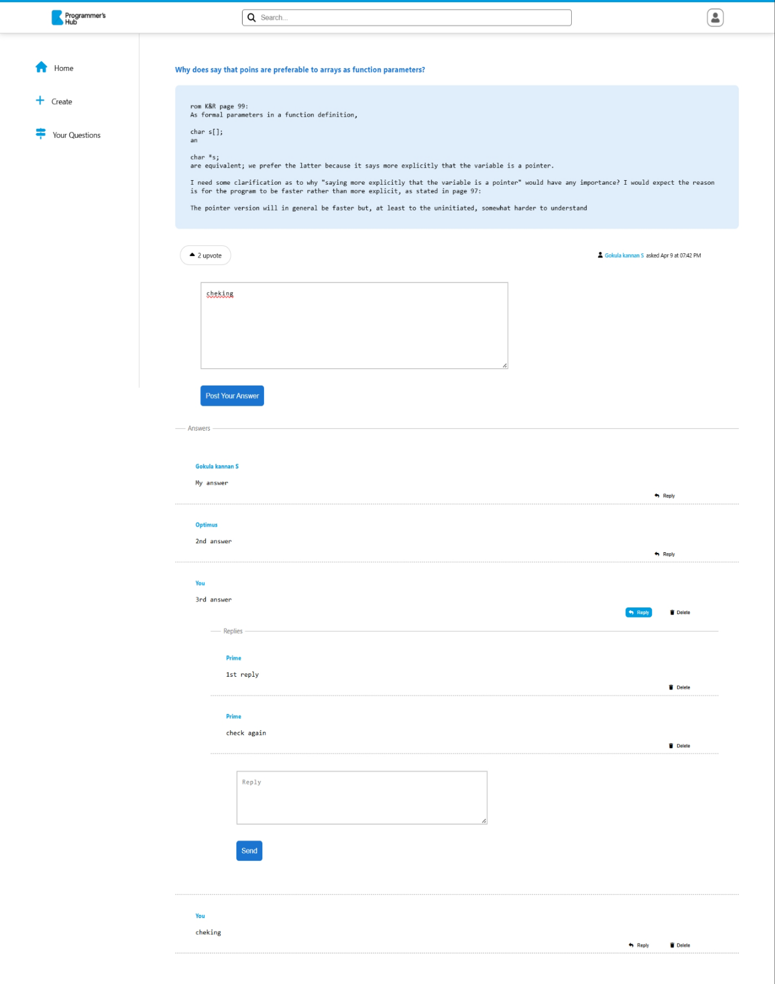

* **Ask Question**

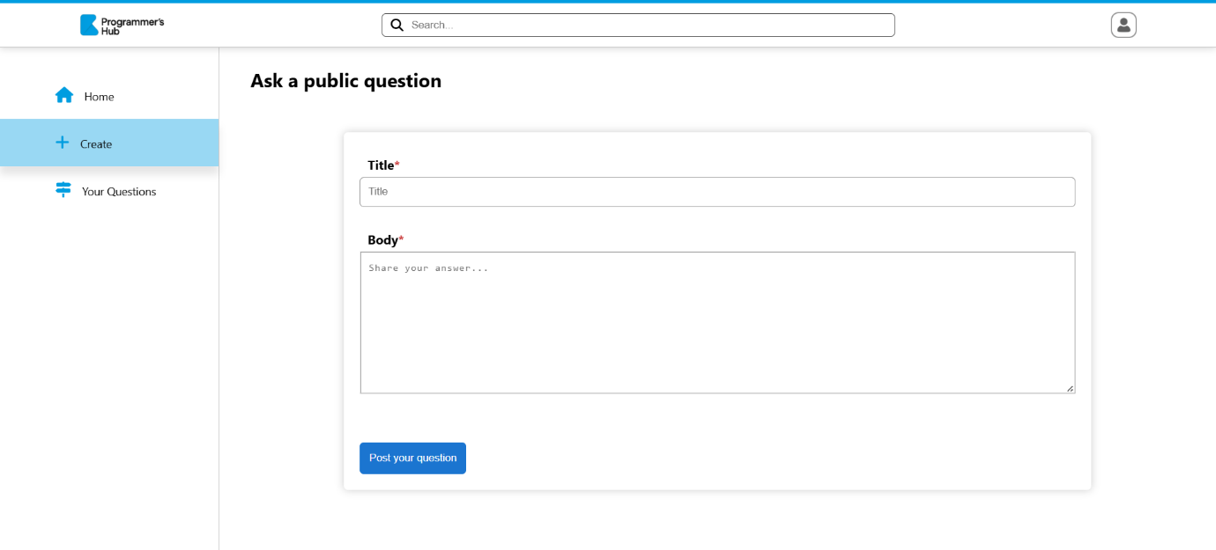

* **User Questions**

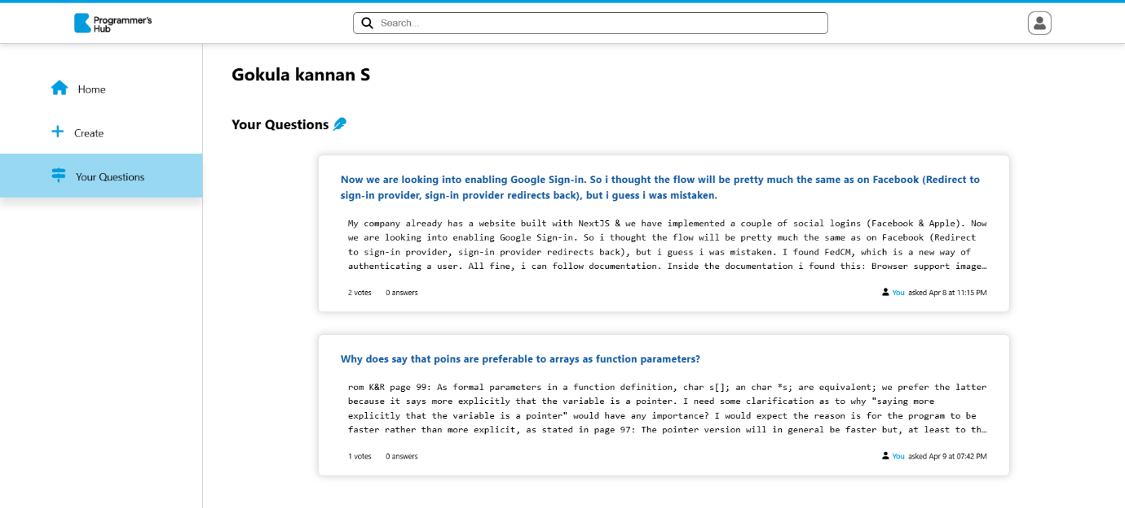

* **Edit Question**

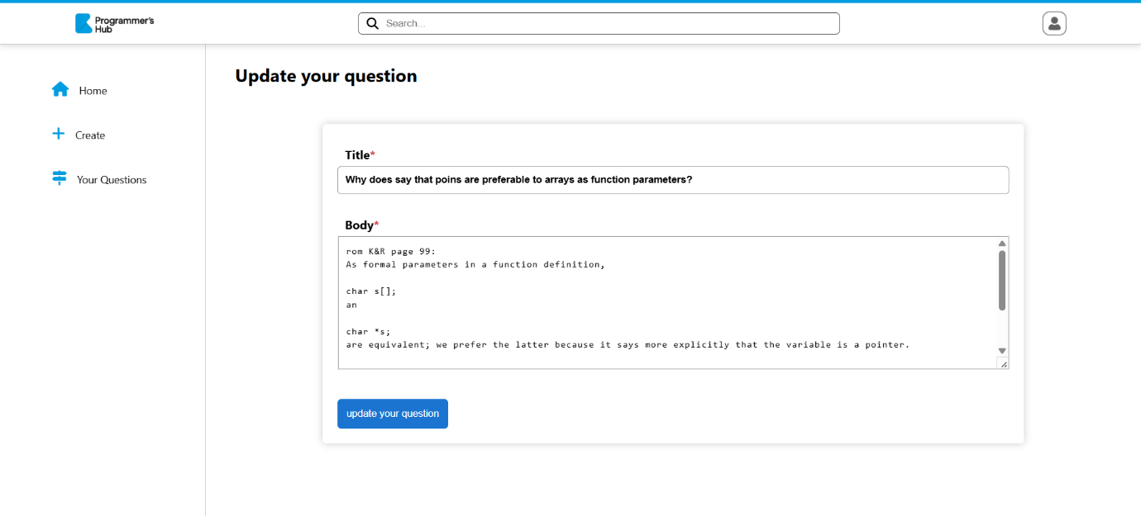

* **Logout Option**

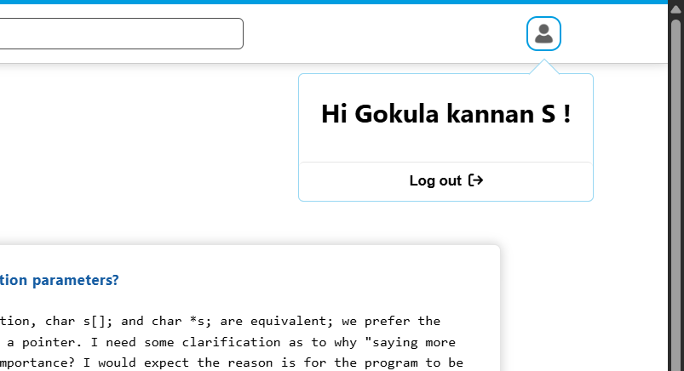

# 9. **Conclusion**

Programmer’s Hub stands as a strong learning project for aspiring full-stack developers, showcasing the effective use of the MERN stack to build a secure, interactive, and user-friendly Q&A platform. It demonstrates the integration of key features like JWT authentication, CRUD operations, dynamic routing, and responsive UI. The platform encourages knowledge sharing among programmers and supports core functionalities like posting, answering, and user interaction.

With future enhancements such as voting systems, real-time notifications, and tag-based search, Programmer’s Hub has the potential to evolve into a powerful and scalable community platform for developers at all levels.